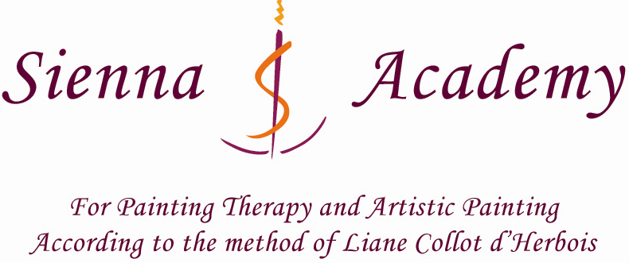

Painting Therapy Training Modules 8 &9 – Yellow/Turquoise
April 16 – May 11 2018
Timetable: 8.30 am – 3.30 pm

In preparation for yellow: Observe and draw yellow in its radiant ray–like appearance with the light behind it, and show how the colour changes as it moves further away from the source of light; observe examples of lemon yellow and golden yellow and write down your experiences of how each worked on you.
In preparation for turquoise: Observe the process of reflection and refraction in the surroundings. Look out for geometrical forces at work in nature. Observe and draw a quartz crystal.

Module 8

Yellow - week 1 April 16 – 20
Charcoal exercise to prepare for veil painting
Yellow veil painting – central light with turquoise and cobalt Blue
Charcoal exercise: morning; mid-day; late afternoon and evening – 4 steps
Sunrise; sunset imaginations to do with colour yellow from Liane’s yellow chapter – moist on moist.

Yellow - week 2 April 23-27
Yellow Rose Exercise – paper 635gms
Moist on moist yellow slanting ray artistic exercise
Yellow slanting ray veil painting - artistic exercise

Theoretical content to include:
Introduction to Yellow
Yellow the expression of cosmic life; the lustre of the spirit
Yellow in relationship to Ancient Sun, The Sun Being Christ and the etheric aura.
Yellow in relationship to the Work of Archangel Michael
Illnesses of the yellow and the healing qualities of yellow.

Module 9

Turquoise – week 1 April 30 – May 4
Charcoal exercise to prepare for veil painting – strong light
Turquoise veil painting for the therapist
Small ‘rose quartz’ veil painting

Turquoise -week 2 May 7 - 11
Turquoise artistic veil painting
Light and darkness ‘Turquoise’ charcoal exercise for the client
Turquoise moist on moist for the client

Theoretical content to include:
Turquoise in connection with the cultural epochs
Turquoise in relationship to the forming forces inherent in the Platonic Forms
Turquoise and its relationship to geometry and spiritual development: the ‘Morally Crystalline’
Geometrical forming forces as a principle of creation
The geometrical form and significance of the ‘Foundation Stone’ of the First Goetheanum
The therapeutic working of Turquoise
Client case studies and related therapy exercises are an integral part of each module

N.B. Medical workshop with Dr. Lakshmi Prasanna - dates to be announced
The program may be subject to changes.
(Courses are taught by Sally Martin unless otherwise stated)

