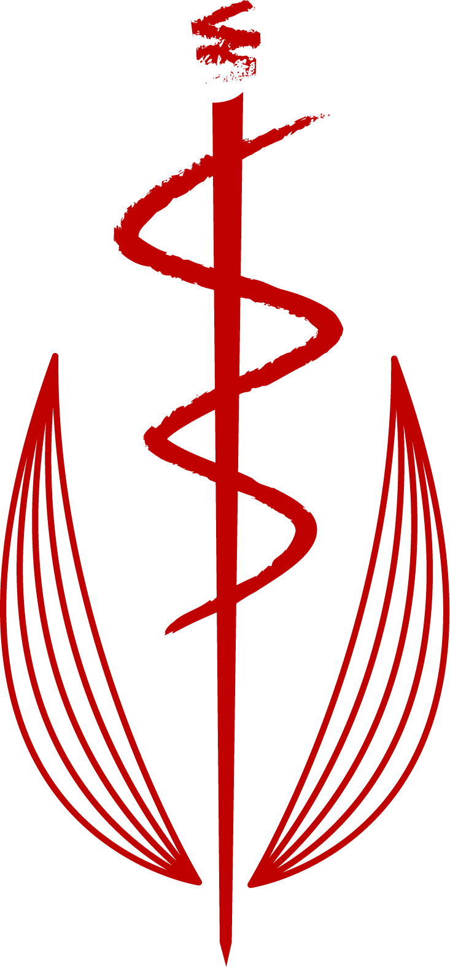 A A M A
Australian Anthroposophic Medicine Association

“HEART THINKING”
SCHOOL of SPIRITUAL SCIENCE STUDY AFTERNOON
Melbourne, Sophia Mundi Steiner School
Sunday afternoon, 30 October 2016
(following the morning AGM 2-5.30pm)

The afternoon will begin with creating Eurythmy and Drama/story depictions of heart-thinking, exploring the processes that occur on a supersensible level within the human being in heart-thinking. This will be centred on the heart, with the aspects of ourselves, other beings and forces within and without ourselves that influence our heart and its capacity to “think”, discern and make choices in a truly free, warm, and human way. Scenarios that illustrate our choices, distractors and helpers and possibilities for developing ourselves and transforming old patterns will be part of this work together. (Lisa Devine)

Following this, there will be separate group work for First-Class members, and non-First Class members (Lisa Devine, Dr Narelle Savage).

All therapists, nurses, veterinarians and doctors who are earnestly interested in spiritual development in ourselves, and with our patients, out of Anthroposophic Medicine are welcome to this study afternoon.

To cover costs - $35 ($25 concession)
Please advise Narelle if you will be attending : Ph 0411024313; E narellefs@hotmail.com

Looking ahead to 2017:-
~ March 2017: We will have a weekend in Byron Bay area, with Patries Orange (Eurythmy Therapist) and others, open to all AAMA and other medical individuals who are interested. Final date to be decided. It is likely that we will continue this work on deepening our understanding of heart thinking, and its relevance to our medical/therapeutic work and professional and personal development, including its relationship to the First Class Lessons.

~ First Class medical member only weekend dates to be discussed at IPMT 2016.

Dr Narelle Savage, July 2016
(for the AAMA Board, Cristina Rubsamen, Ellen Sallows, Michael Kokinos)

